User Manual for C-Power11SN Parameter Setting

enter the parameter setting interface of the setting tool
Open the operating software“LedCenterM6.00-3.exe” Click on “Find" to enter the screen definition interface,as shown in the following figure:
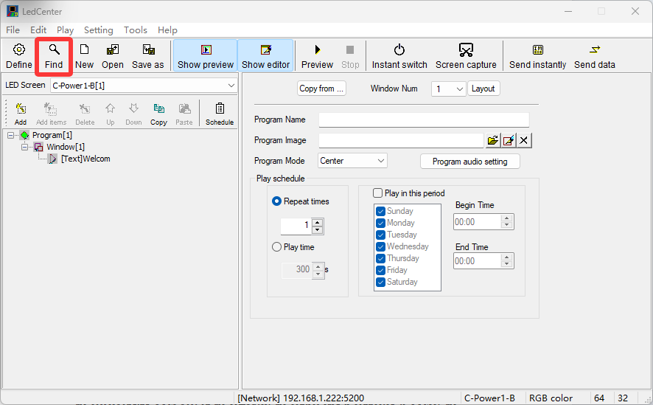

Set communication parameters
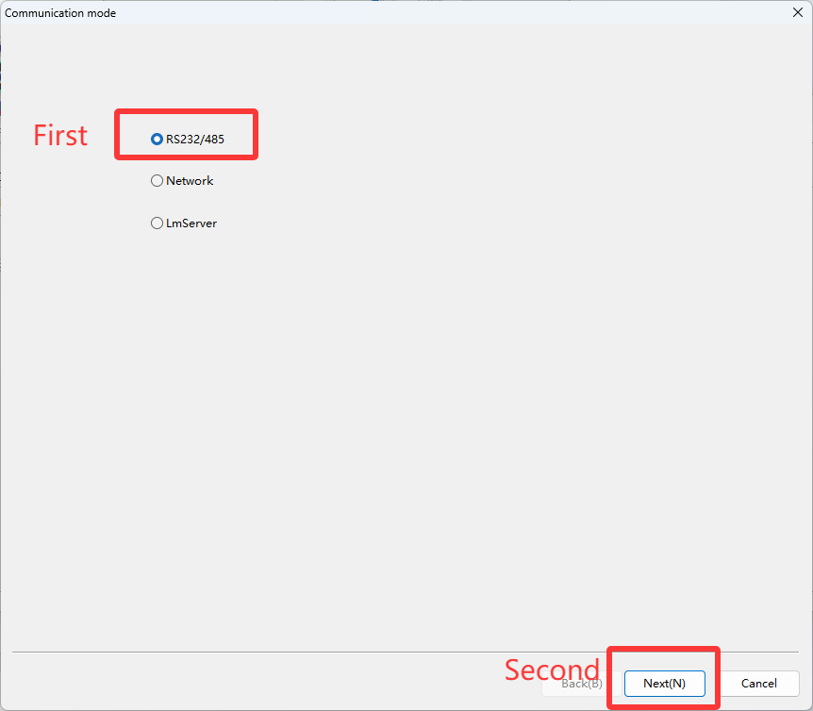
1.Serial communication: After”Find”,select serial port,that is, RS232/485 on the interface. the serial port is the control card connected to the corresponding COM port on the computer, the control card is connected to COM1, the original parameters of the control card before delivery are: baudrate is 115200, ID is 1, After the selection click “Next”.

2. Network port communication:After”Find”,click the “Network”.The original parameters of the controller card before delivery are: IP address: 192.168.1.222
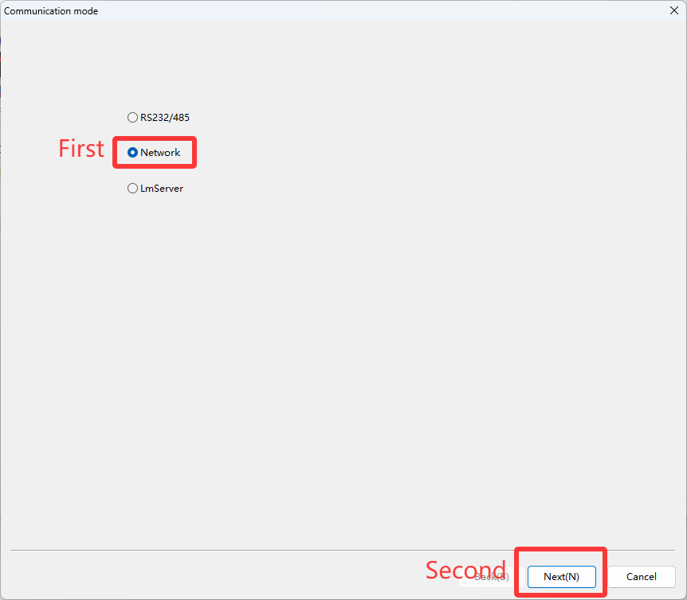
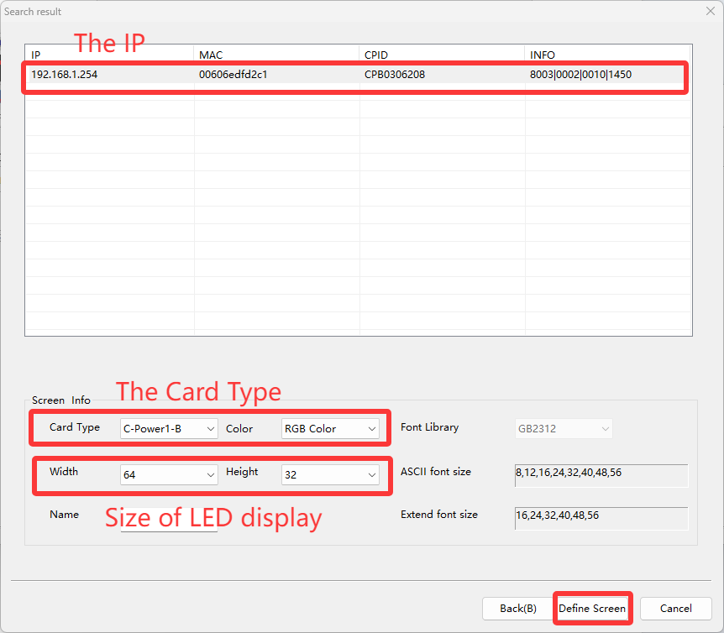
Find your control card based on the IP address and check if it is the card you are looking for in the control card type below. Then adjust the data of LED display screen size, and define the display screen as shown below:

read the control card program version information after reading back successfully
After defining the display screen and returning to the main interface, click on "Tools" at the top and select "Ledtool".
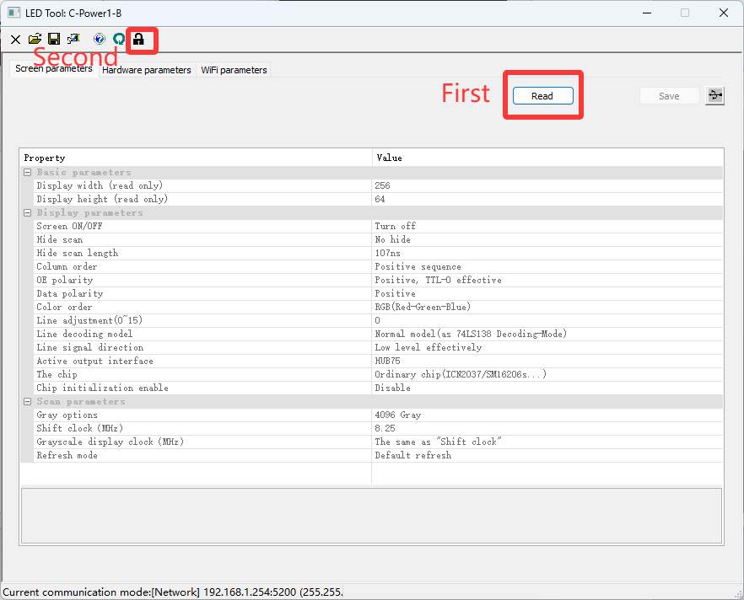
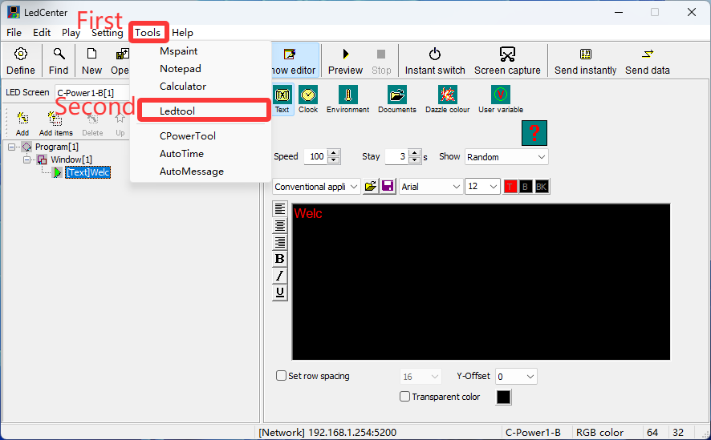
After entering the settings tool, click the "Read" command to parse the screen data. Then click on the lock icon above to unlock, enter password: 26888

Display parameter setting
1. After you click "Read" successfully, the unlocking password is 26888, and then you can set the parameters related to the display screen.
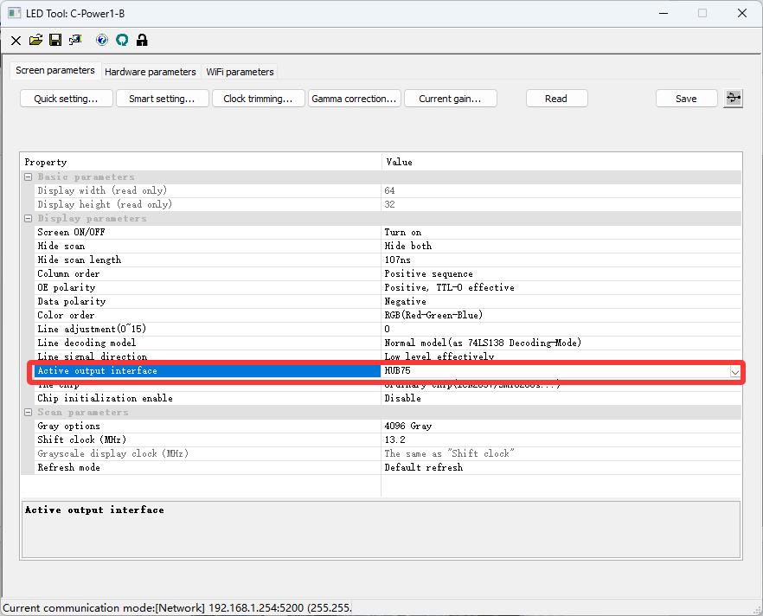
2.Type of output interface

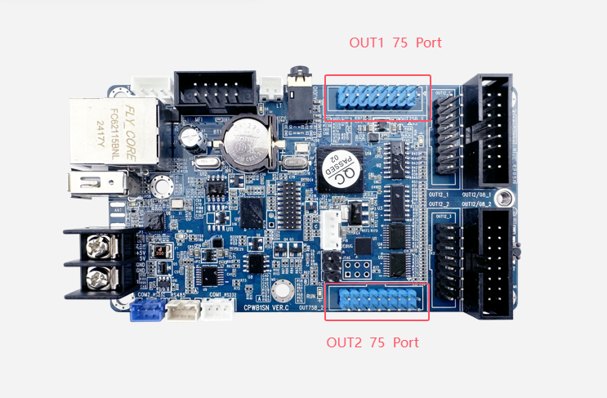
Select the HUB75 interface as shown below
Select the HUB12 port as shown below:
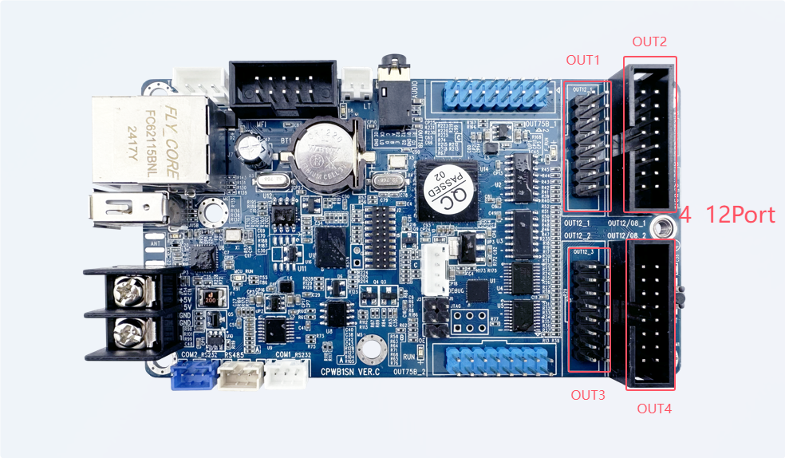

Select port HUB08 as shown in the following figure: OUT1, OUT2 indicates port 08

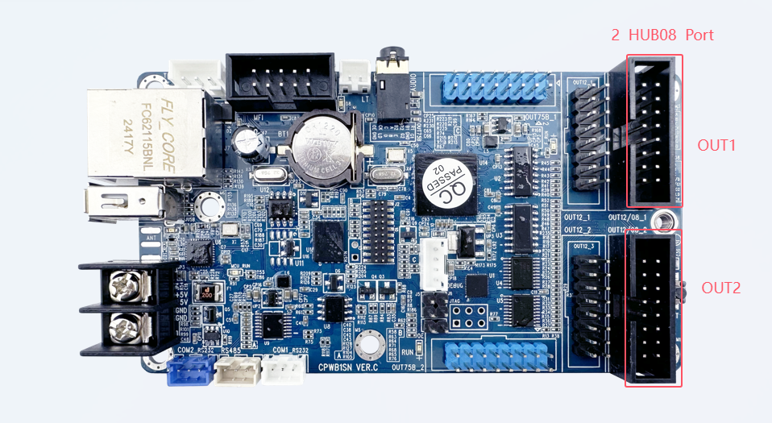
- Smart Settings
The steps are as follows: click "Smart setting", screen type, module size, interface type Input interface signal number, column order, chip type selection.
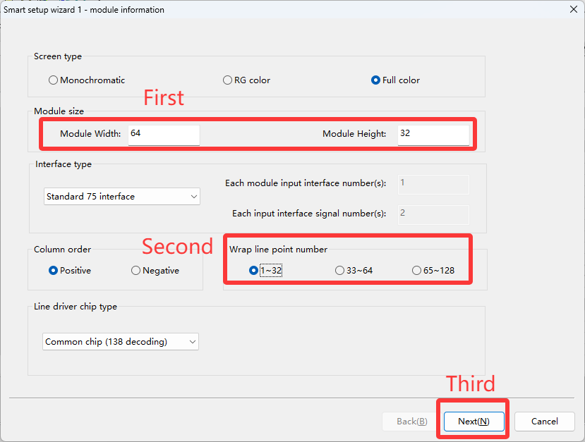
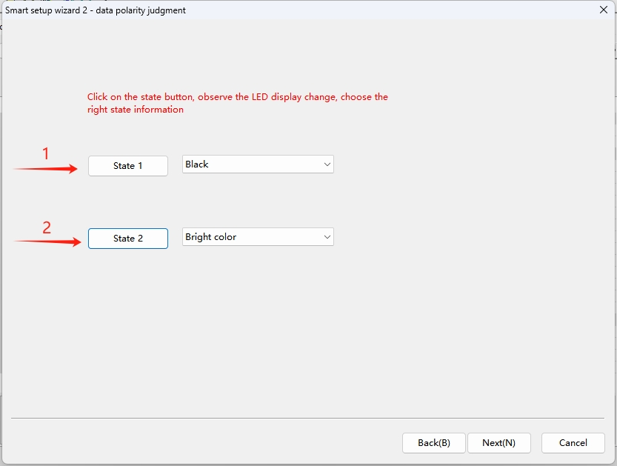

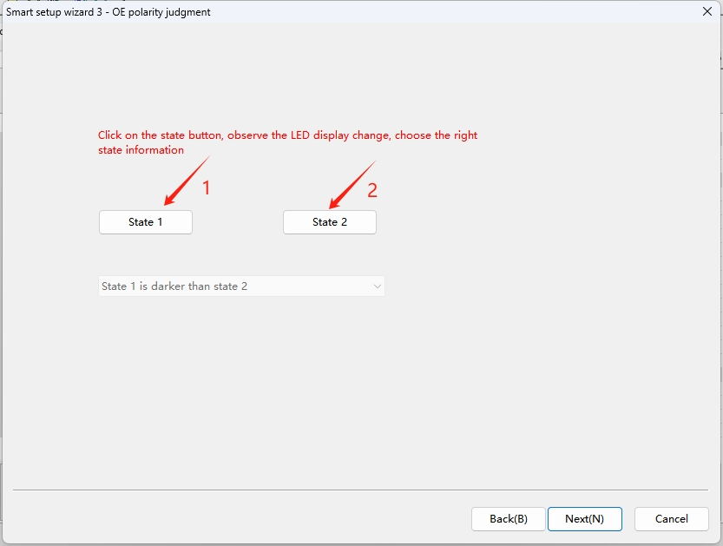

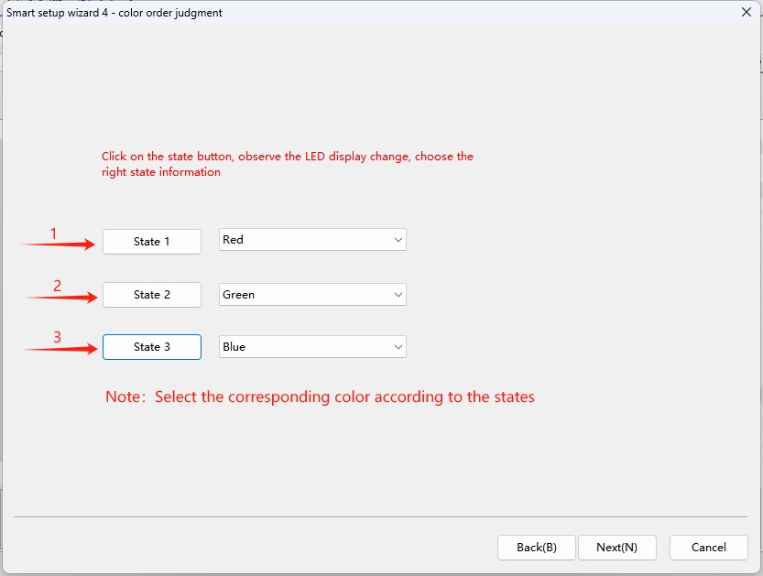

According to the number of bright lines displayed on the display screen, most of the full-color lines are two lines, and the number of black lines is the number of lines between two bright lines. If there is only one bright line, the number of black lines is zero.
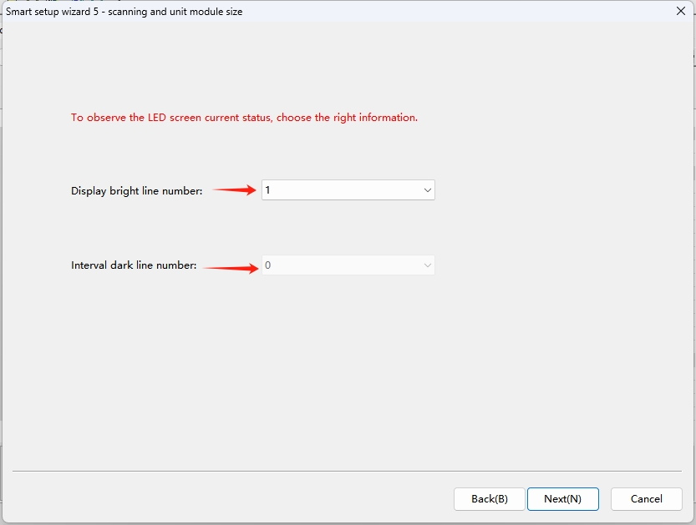
After the previous parameters are set correctly, you can trace points. After the previous parameters are correct, a bright spot will appear in the module, and trace points according to the location of the bright spot. (If you connect multiple modules, just look at the module connected to OUT1 for tracing Settings)
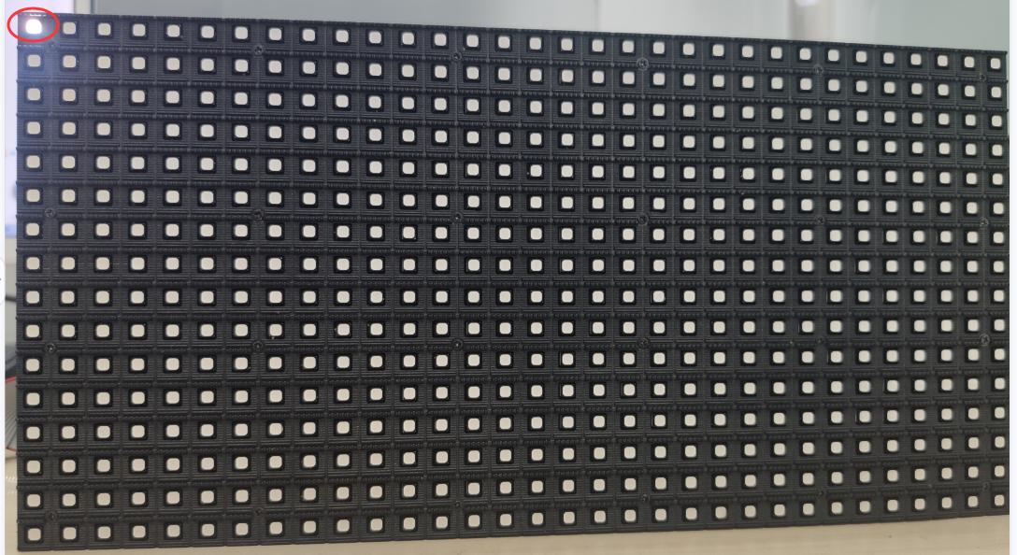

As shown in the figure, the module highlight is the first point, click the first point, and trace the point once, according to the highlight of the module

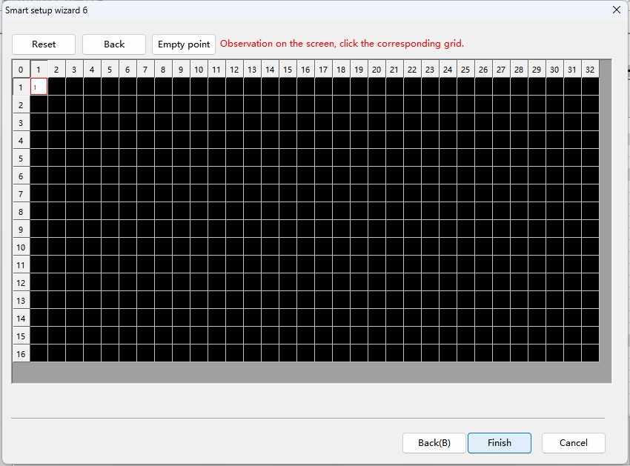
After the successful stroke, the intelligent setting is complete. Click the Save button
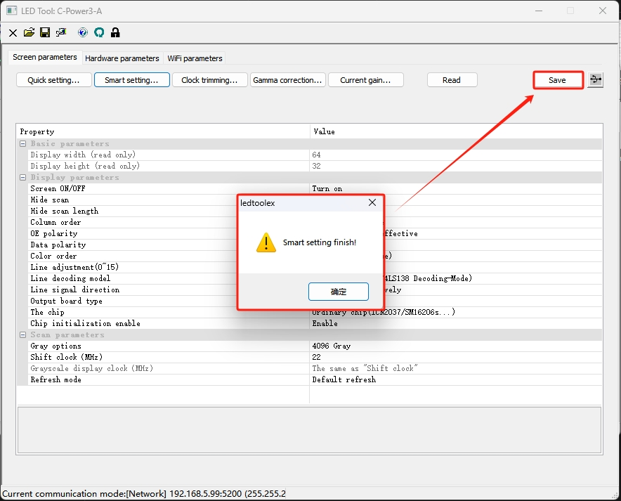
is to export all parameters to the computer to save

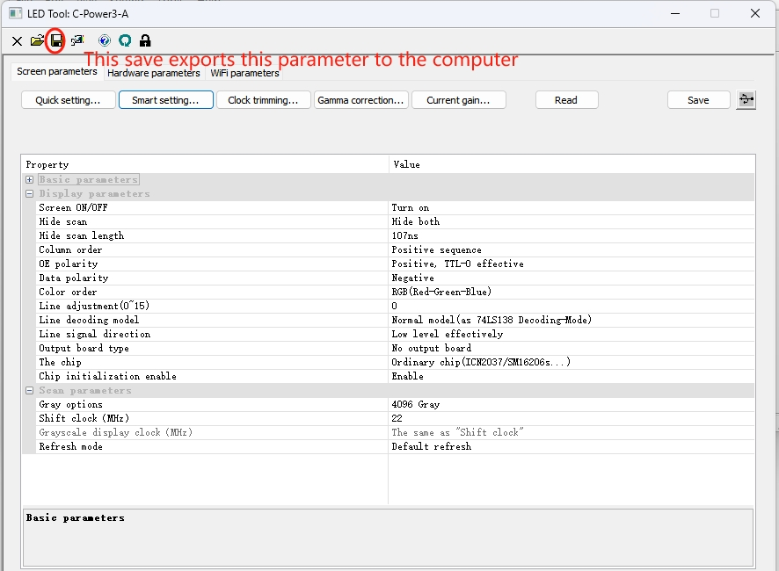
Export and save the screen parameter Settings, as shown in the figure:
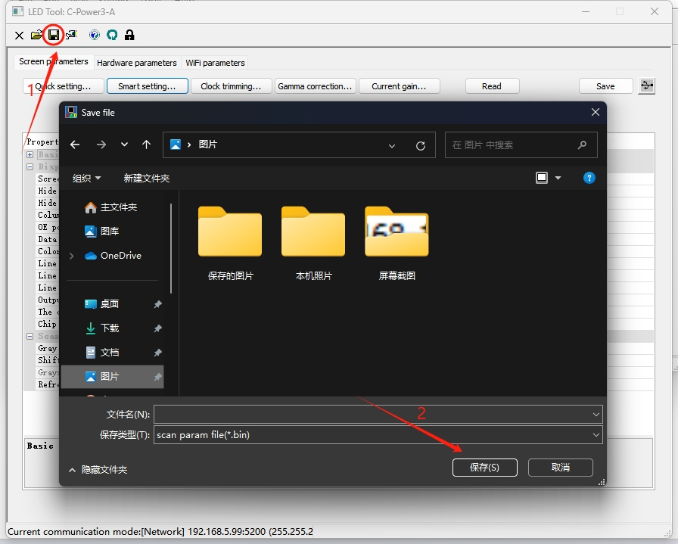
You can also import the previously saved screen parameter Settings, as shown in the figure：
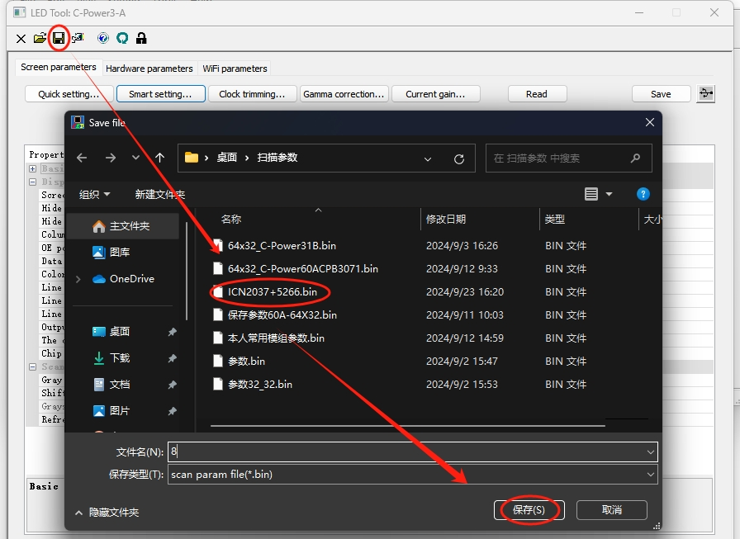

Hardware parameter Settings
- You can read the hardware parameters of the controller card on the hardware parameters screen. The original parameters of the controller card before delivery are as follows: Device IP address: 192.168.1.222, IP mask: 255.255.255.0, gateway: 192.168.1.1;As shown in the picture:
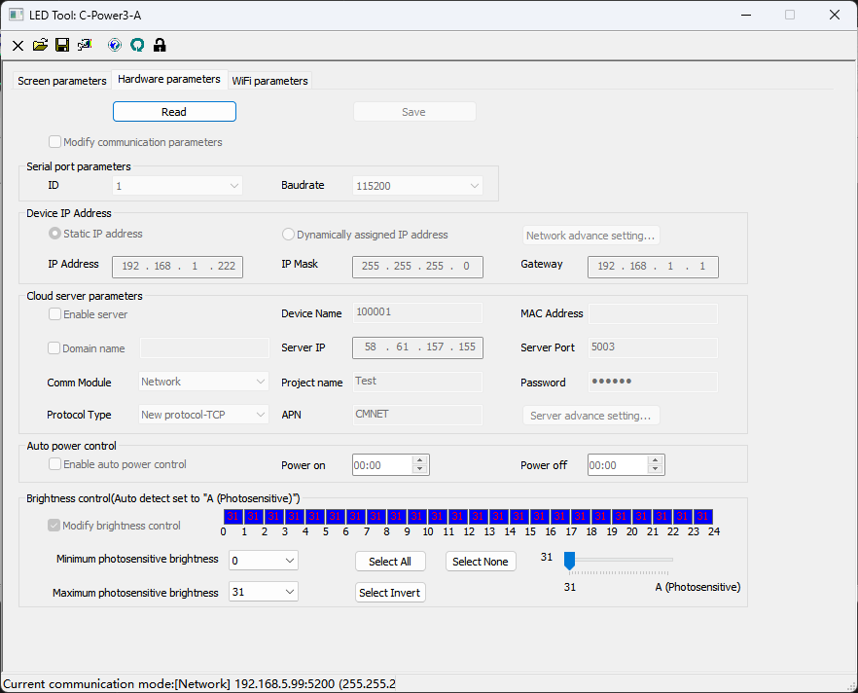
- You can reset the hardware parameter data of the control card: first read back and then unlock, and the password is "26888", then select Modify communication parameters, reset the communication interface parameters of the control card, click "Save", and restart the control card after the saving is successful.
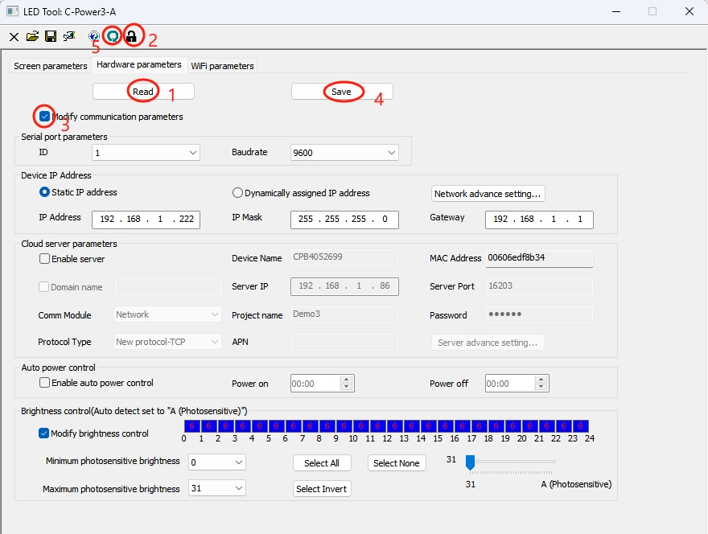
Password:26888
- Modify the WIFI parameters of the control card
1.AP mode is equivalent to controlling the card as a router, which can be directly connected
The image settings are for reference only, and the actual parameters need to be filled in according to the actual situation
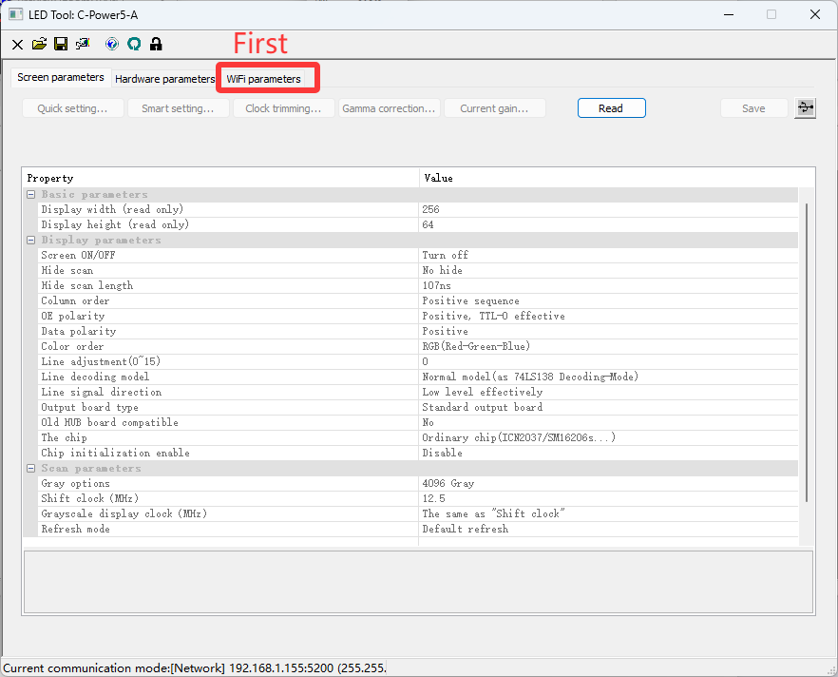
2.After completing the steps shown in the above diagram, click according to the following diagram. In the third step, click on the "lock" icon and enter the password: 26888. Then, you can change the parameters of WIFI
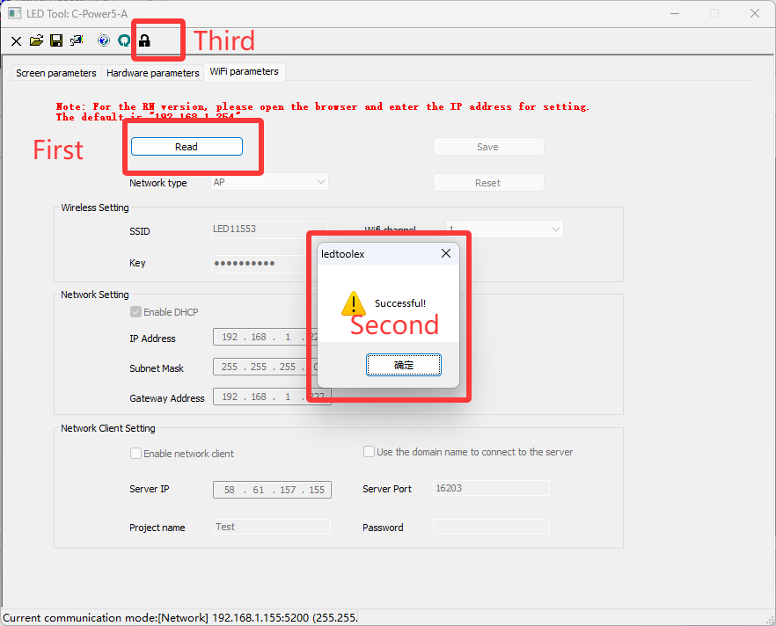
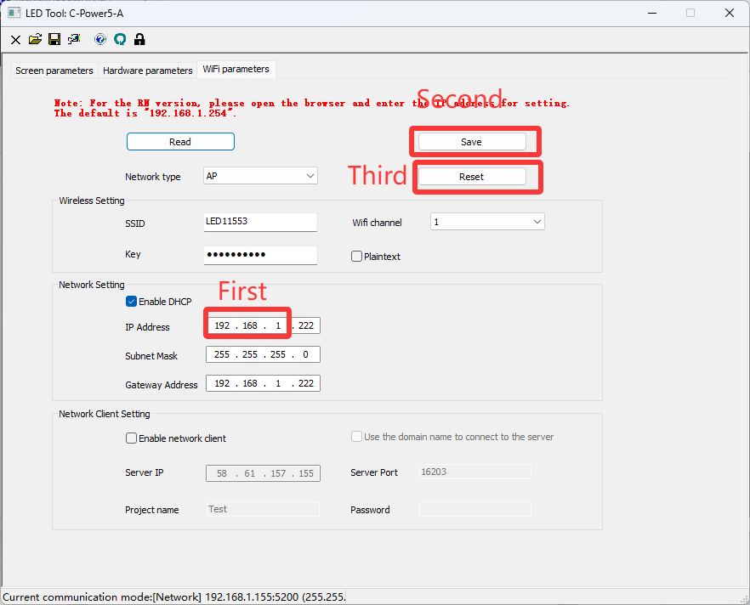
3.Please ensure that the WIFI network segment is the same as the network segment of the control card, that is, the part circled by the red box in the first step of the picture, and the first three segments of the IP address are the same. Then click on the second step to save, and restart the control card in the third step to make the WIFI parameters you just modified take effect.

